COS 10026 Assignment 1
Name: Nur E Siam
Student ID: 103842784

Introduction
As a part of our group project, we were assigned to make a web page. My team members and I chose the topic “Computers and Laptops” and we assigned each member an individual webpage to work on to complete the website. The website’s content focuses on laptops and various computer components, such as different laptop brands, GPU and monitors.
This project’s main goal was to work as a whole and deliver a webpage which will showcase our skills on HTML and CSS that we have learned through the course.
This report documents my contribution to the project, the key features of the website and the process of the website’s creation.

Website content
Our website has in total five pages: Home page, Product page, About Us page, Enquiries and Enhancement page. The Home page introduces the user about the chosen product and the company behind the website, Pixel-8. As for the Product page, it gives the user a brief description about the different laptop and computer parts. It compares one GPU to another and states the differences between them. The user is free to select whichever suits their taste. The About Us page provides a short biography of the team that created the website, including their photos and class timetable. The enquiry page thoroughly gathers the user’s information so that the company can get back to them. The enhancement page provides information about the content of the website and other important features about the website.
Since, our work was limited to one style sheet for the whole website, the team had to be specific with the names assigned to <div> in the HTML code. Throughout this website we use <h1> to ensure that it will be the first thing the user notices when they load into the page. In the product page we used <table> to provide information about laptop’s specification. We used <form> and <fieldset > to create the enquiry page.

Sitemap

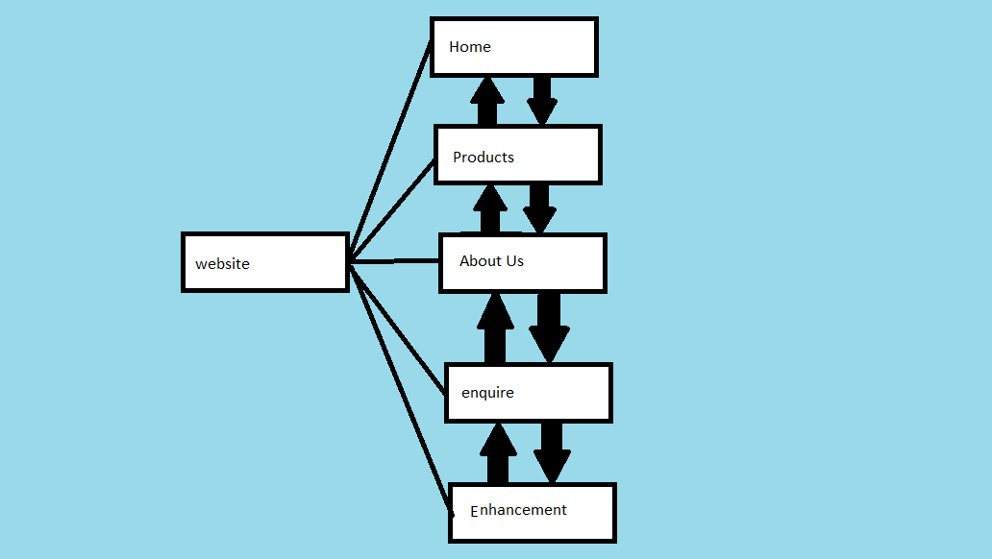

Website Style

To increase readability, we decided to go with a clean and sleek theme. The main colours used were blue and black. Since the website contains a lot of information that the user will have to take in, the main pages had to have enough breathing space between each section.
Because, the website will look different on various screen sizes, we decided to use percentages instead of fixed pixels for the widths and heights for certain elements, eg. <width: 100%>. This way the aspect ratio will remain constant through all resolutions.
To center align some elements within containers, <margin: auto> was used to make sure that the elements would remain in the center, no matter the screen dimension. <button: hover> was also used to implement the colour change when the user hovered over the Buy button or Learn More button.

Screenshots
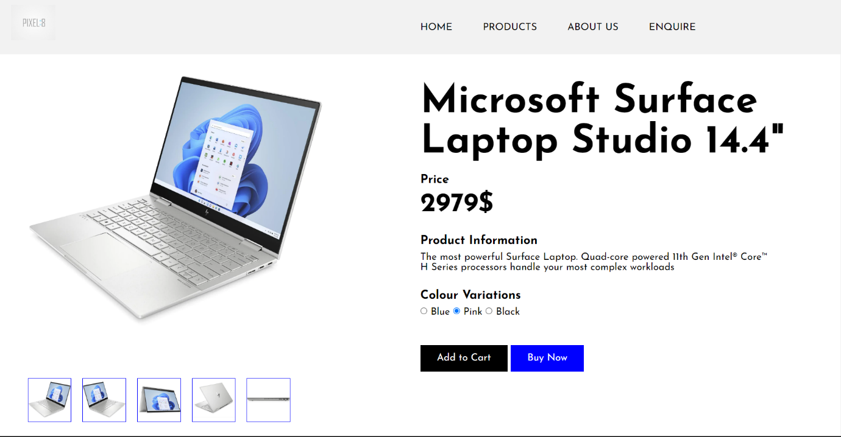

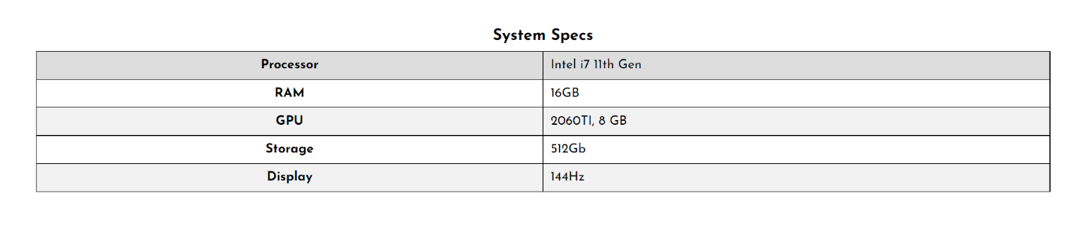

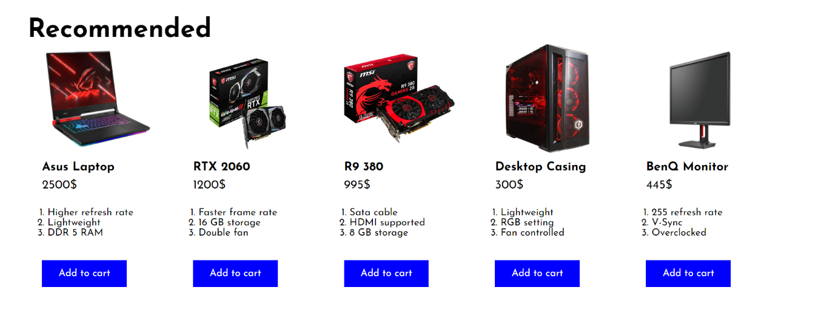

Key Feature
The key feature of this webpages would be theme, hover effect and Image gallery.
As for my enhancements, I did the hover effect for the navigation bar and table in the product page. When the user hovers their cursor over the Add to Cart or Buy button, the blue button changes to black. For the navigation bar, the buttons linking the user to the other pages, changes to blue and an underline appears to show the selection. The table in the product page has a hover effect to improve readability.

Personal Contribution
My main task was to create the product page. I also integrated the navigation bar and footer into everybody’s HTML code. This was a particularly difficult task to accomplish because of conflict in the merge of CSS code. To make the website look cohesive, I designed the simple blue and black theme and implemented it in the Home and Product page. I ensured that information is evenly spaced out in the pages by adding <padding-top: 50px> to <div> elements. Moreover, I also aid the team leader in the production of the YouTube video for our website.

Conclusion
In conclusion, my team worked together to create one cohesive website that showcases the information about laptops and computer components. The key feature of the website is the hover effect. This is kept simple so that the user will not feel overwhelmed as the website is information heavy.
In the future, it would be a good idea to settle the colour scheme of the website first. If not, everyone will come out with their own version, and it will be a headache to clean e https://www.dhgate.com/product/ipason-gaming-pc-amd-4-core-3-7ghz-amd-radeon/551479445 verything up.

References
The image references for my product.html file is shown below.
- https://www.jbhifi.com.au/products/microsoft-surface-laptop-studio-14-4-i7-512gb-16gb-platinum?queryID=5a78238c02e5e91cae63e99a4d496eb2&objectID=520101
- https://www.notebookcheck.net/All-AMD-Asus-ROG-Strix-G15-gaming-laptop-with-Ryzen-9-5980HX-and-Radeon-RX-6800M-back-on-sale-with-a-US-300-discount.639702.0
- https://www.amazon.com.au/ASUS-Graphics-Powerful-Axial-tech-DUAL-RTX2060-O6G-EVO/dp/B07V1Y6Y2J
- https://www.msi.com/Graphics-Card/R9-380-GAMING-2G/Specification
- https://www.dhgate.com/product/ipason-gaming-pc-amd-4-core-3-7ghz-amd-radeon/551479445
- https://www.centrecom.com.au/benq-zowie-xl2411k-144hz-dyac-24-inch-esports-gaming-monitor

